4. Create an application to develop Login window using UI controls.

Activity_main.xml File:

<?xml version="1.0" encoding="utf-8"?>
<RelativeLayout
xmlns:android="http://schemas.android.com/apk/res/android"
xmlns:app="http://schemas.android.com/apk/res-auto"
xmlns:tools="http://schemas.android.com/tools"
android:layout_width="match_parent"
android:layout_height="match_parent"
android:background="@drawable/img_4"
tools:context=".MainActivity">

<TextView android:text = "Login Page"
android:layout_width="wrap_content"
android:layout_height = "wrap_content"
android:id = "@+id/textview"
android:textSize = "40dp"
android:textColor="@color/black"
android:layout_alignParentTop = "true"
android:layout_centerHorizontal = "true" />

<TextView
android:layout_width = "wrap_content"
android:layout_height = "wrap_content"
android:text = "Surana College"
android:id = "@+id/textView"
android:layout_below = "@+id/textview"
android:layout_centerHorizontal = "true"
android:textColor = "#ff7aff24"
android:textSize = "35dp" />

<EditText
android:layout_width = "wrap_content"
android:layout_height = "wrap_content"
android:id = "@+id/editText"
android:hint = "Enter Name"
android:focusable = "true"
android:textColorHighlight = "#ff7eff15"
android:textColorHint = "#FFFFFFFF"
android:layout_marginTop = "46dp"
android:layout_below = "@+id/imageView"
android:layout_alignParentLeft = "true"
android:layout_alignParentStart = "true"
android:layout_alignParentRight = "true"
android:layout_alignParentEnd = "true" />

<ImageView
android:layout_width="wrap_content"
android:layout_height="200dp"
android:id="@+id/imageView"
android:src="@drawable/img"
android:layout_below="@+id/textView"
android:layout_centerHorizontal="true" />

<EditText
android:layout_width="wrap_content"
android:layout_height="wrap_content"
android:inputType="textPassword"
android:ems="10"
android:id="@+id/editText2"
android:layout_below="@+id/editText"
android:layout_alignParentLeft="true"
android:layout_alignParentStart="true"
android:layout_alignRight="@+id/editText"
android:layout_alignEnd="@+id/editText"
android:textColorHint="#FFFFFFFF"
android:hint="Password" />

<TextView
android:layout_width="wrap_content"
android:layout_height="wrap_content"
android:text="Attempts Left:"
android:id="@+id/textView2"
android:layout_below="@+id/editText2"
android:layout_alignParentLeft="true"
android:layout_alignParentStart="true"
android:textColor="@color/black"
android:textSize="25dp" />

<TextView
android:layout_width="wrap_content"
android:layout_height="wrap_content"
android:text="New Text"
android:id="@+id/textView3"
android:layout_alignTop="@+id/textView2"
android:layout_alignParentRight="true"
android:layout_alignParentEnd="true"
android:layout_alignBottom="@+id/textView2"
android:layout_toEndOf="@+id/textview"
android:textSize="25dp"
android:textColor="@color/black"
android:layout_toRightOf="@+id/textview" />

<Button
android:layout_width="wrap_content"
android:layout_height="60dp"
android:text="login"
android:id="@+id/button"
android:layout_alignParentBottom="true"
android:layout_toLeftOf="@+id/textview"
android:layout_marginTop="100dp"
android:layout_toStartOf="@+id/textview" />

<Button
android:layout_width="wrap_content"
android:layout_height="60dp"
android:text="Cancel"
android:id="@+id/button2"
android:layout_alignParentBottom="true"
android:layout_toRightOf="@+id/textview"
android:layout_toEndOf="@+id/textview" />

</RelativeLayout>

MainActivity.java File:

package com.ashakanoj.program5;
import androidx.appcompat.app.AppCompatActivity;
import android.content.Intent;
import android.os.Bundle;
import android.graphics.Color;
import android.view.View;
import android.widget.Button;
import android.widget.EditText;
import android.widget.TextView;
import android.widget.Toast;

public class MainActivity extends AppCompatActivity {

Button b1,b2;
EditText ed1,ed2;

TextView tx1;
int counter = 3;

@Override
protected void onCreate(Bundle savedInstanceState) {
super.onCreate(savedInstanceState);
setContentView(R.layout.activity_main);

b1 = (Button)findViewById(R.id.button);
ed1 = (EditText)findViewById(R.id.editText);
ed2 = (EditText)findViewById(R.id.editText2);

b2 = (Button)findViewById(R.id.button2);
tx1 = (TextView)findViewById(R.id.textView3);
tx1.setVisibility(View.GONE);

b1.setOnClickListener(new View.OnClickListener() {
@Override
public void onClick(View v) {
if(ed1.getText().toString().equals("admin") &&
ed2.getText().toString().equals("admin")) {
Toast.makeText(getApplicationContext(),
"Redirecting...Login Successful !!!",Toast.LENGTH_SHORT).show();

}else{
Toast.makeText(getApplicationContext(), "Wrong Credentials",Toast.LENGTH_SHORT).show();

tx1.setVisibility(View.VISIBLE);
tx1.setBackgroundColor(Color.RED);
counter--;
tx1.setText(Integer.toString(counter));
if (counter == 0) {
b1.setEnabled(false);
}
}
}
});
b2.setOnClickListener(new View.OnClickListener() {
@Override
public void onClick(View v) {
}
});
}
}
Output:

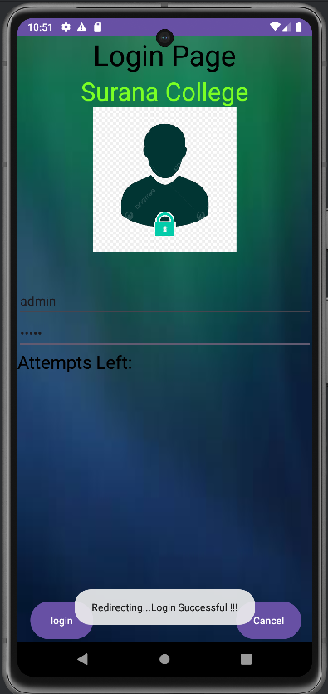
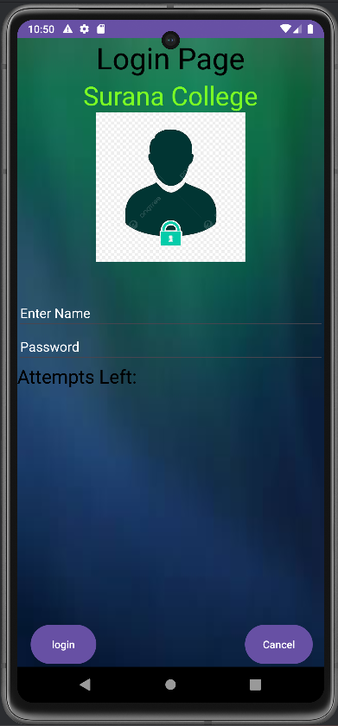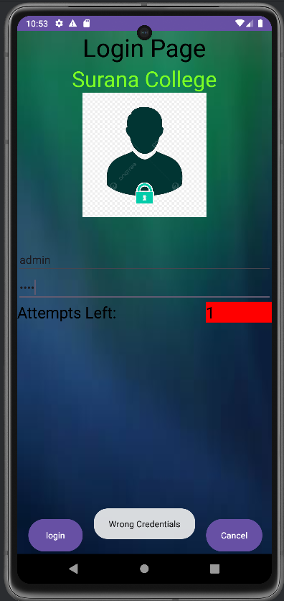
6. Create an UI with all views.

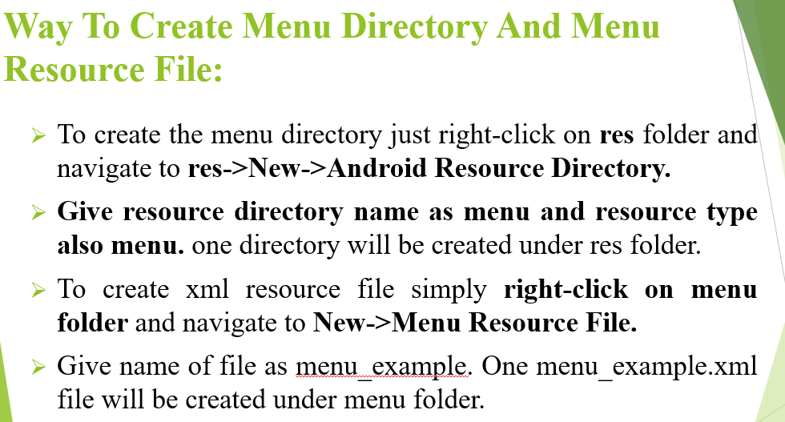

activity_main.xml file:

<?xml version="1.0" encoding="utf-8"?>
<LinearLayout
xmlns:android="http://schemas.android.com/apk/res/android"
android:layout_width="fill_parent"
android:layout_height="fill_parent"
android:orientation="vertical"
android:paddingBottom="@dimen/activity_verticle_margin"
android:paddingLeft="@dimen/activity_horizontal_margin"
android:paddingRight="@dimen/activity_horizontal_margin"
android:paddingTop="@dimen/activity_verticle_margin">

<TextView
android:id="@+id/textView"
android:layout_width="match_parent"
android:layout_height="wrap_content"
android:text="Hello Students!!" />

<Button
android:id="@+id/buttonExample"
android:layout_width="match_parent"
android:layout_height="wrap_content"
android:text="Example Button" />

<CheckBox
android:id="@+id/checkBoxExample"
android:layout_width="match_parent"
android:layout_height="wrap_content"
android:text="CheckBox Example" />

<ToggleButton
android:id="@+id/toggleButtonExample"
android:layout_width="wrap_content"
android:layout_height="wrap_content"
android:text="ToggleButton Example" />

<RadioGroup
android:id="@+id/radioGroupExample"
android:layout_width="wrap_content"
android:layout_height="wrap_content" >

<RadioButton
android:id="@+id/radioBtton1"
android:layout_width="wrap_content"
android:layout_height="wrap_content"
android:checked="true"
android:text="RadioButton 1" />

<RadioButton
android:id="@+id/radioButton2"
android:layout_width="wrap_content"
android:layout_height="wrap_content"
android:text="RadioButton 2" />
<RadioButton
android:id="@+id/radioButton3"
android:layout_width="wrap_content"
android:layout_height="wrap_content"
android:text="RadioButton 3" />
</RadioGroup>
<ImageButton
android:id="@+id/imageButtonExample"
android:layout_width="match_parent"
android:layout_height="wrap_content"
android:src="@drawable/baseline_airline_seat_recline_normal_24" />

</LinearLayout>

Main.xml file:
<?xml version="1.0" encoding="utf-8"?>
<menu xmlns:android="http://schemas.android.com/apk/res/android">
</menu>

dimen.xml file:
<?xml version="1.0" encoding="utf-8"?>
<resources>
<dimen name="activity_verticle_margin">100dp</dimen>"
<dimen name="activity_horizontal_margin">100dp</dimen>
</resources>
MainActivity.java File:
package com.ashakanoj.program4;

import androidx.appcompat.app.AppCompatActivity;

import android.os.Bundle;
import android.view.Menu;
import android.view.View;
import android.widget.Button;
import android.widget.CheckBox;
import android.widget.ImageButton;
import android.widget.RadioButton;
import android.widget.RadioGroup;
import android.widget.RadioGroup.OnCheckedChangeListener;
import android.widget.Toast;
import android.widget.ToggleButton;

public class MainActivity extends AppCompatActivity {

@Override
protected void onCreate(Bundle savedInstanceState) {
super.onCreate(savedInstanceState);
setContentView(R.layout.activity_main);
Button example = (Button) findViewById(R.id.buttonExample);

CheckBox exampleCheckBox = (CheckBox) findViewById(R.id.checkBoxExample);
RadioGroup exampleRadioGroup = (RadioGroup) findViewById(R.id.radioGroupExample);
ToggleButton exampletoggleButton = (ToggleButton) findViewById(R.id.toggleButtonExample);
ImageButton exampleImageButton = (ImageButton) findViewById(R.id.imageButtonExample);

example.setOnClickListener(new View.OnClickListener() {

@Override
public void onClick(View arg0) {
// TODO Auto-generated method stub

// Toast.makeText(this, "Hey Button is pressed !!",
// Toast.LENGTH_SHORT).show();
ToastToDisplay("Hey Button is pressed!!");
}
});
exampleCheckBox.setOnClickListener(new View.OnClickListener() {
@Override
public void onClick(View v) {
// TODO Auto-generated method stub
if (((CheckBox) v).isChecked()) {
ToastToDisplay("Check Box is checked");
} else {
ToastToDisplay("Check box is unchecked");
}
}
});
exampleRadioGroup
.setOnCheckedChangeListener(new OnCheckedChangeListener() {
@Override
public void onCheckedChanged(RadioGroup group, int checkedId) {
// TODO Auto-generated method stub
RadioButton rb1 = (RadioButton) findViewById(R.id.radioBtton1);
RadioButton rb2 = (RadioButton) findViewById(R.id.radioButton2);
if (rb1.isChecked()) {
ToastToDisplay("Radio Button 1 is checked");
} else if (rb2.isChecked()) {
ToastToDisplay("Radio Button 2 is checked");
} else {
ToastToDisplay("Radio Button 3 is checked");
}
}
});
exampletoggleButton.setOnClickListener(new View.OnClickListener() {
@Override
public void onClick(View v) {
// TODO Auto-generated method stub
if (((ToggleButton) v).isChecked()) {
ToastToDisplay("Toggle button is ON");
} else {
ToastToDisplay("Toggle Button is OFF");
}
}
});

exampleImageButton.setOnClickListener(new View.OnClickListener() {

@Override
public void onClick(View v) {
// TODO Auto-generated method stub
ToastToDisplay("Image Button is pressed");
}
});
}
private void ToastToDisplay(String args) {
Toast.makeText(getBaseContext(), args, Toast.LENGTH_SHORT).show();
}
@Override
public boolean onCreateOptionsMenu(Menu menu) {
// Inflate the menu; this adds items to the action bar if it is present.
getMenuInflater().inflate(R.menu.main, menu);
return true;
}
}

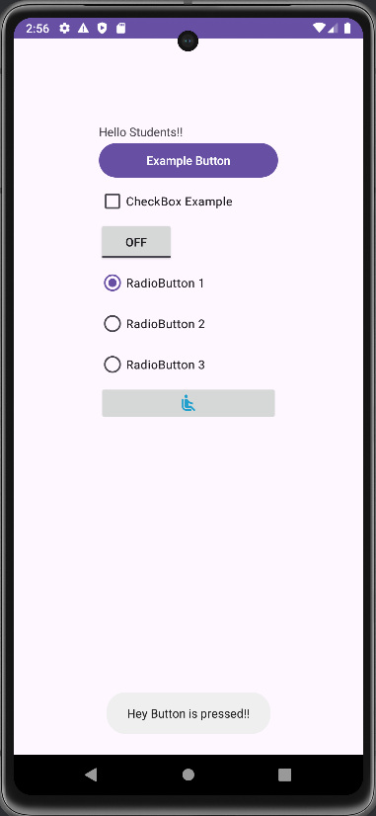
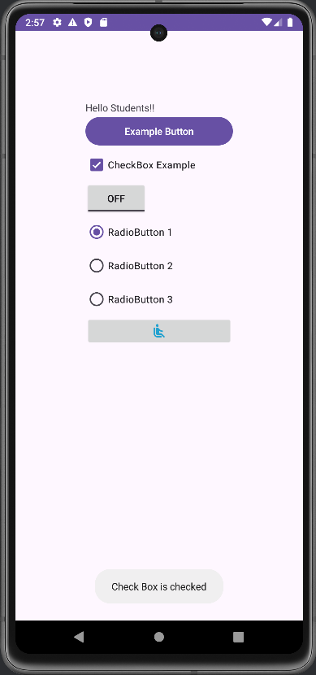
Output:
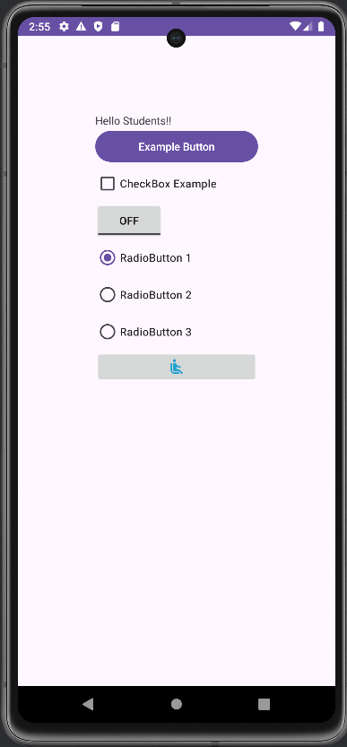
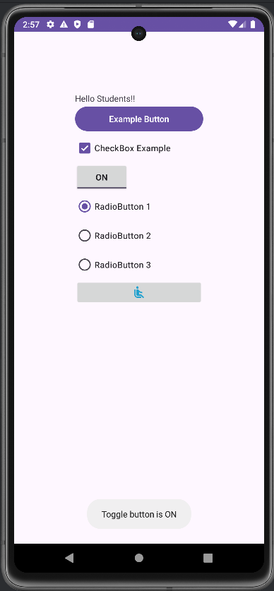
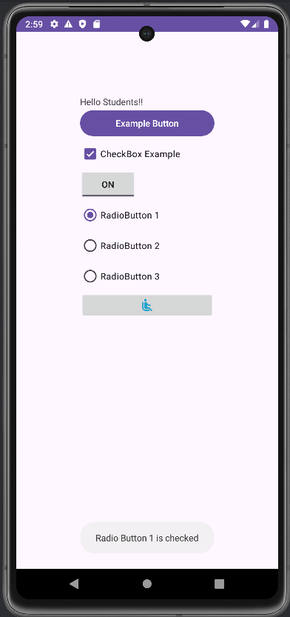
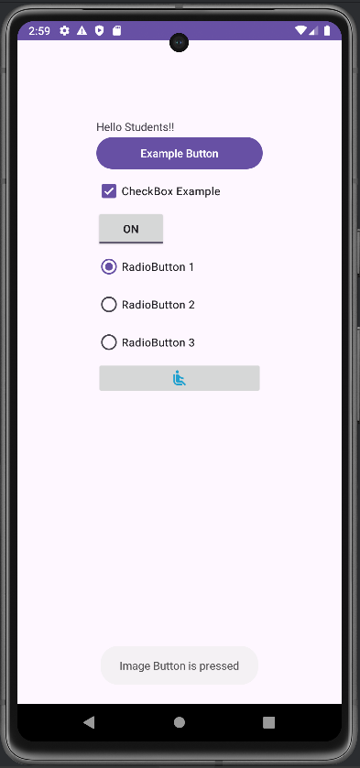
8. Create Menu in Application.

MainActivity.java File:
package com.ashakanoj.program6;
import androidx.appcompat.app.AppCompatActivity;
import android.os.Bundle;
import android.view.ContextMenu;
import android.view.Menu;
import android.view.MenuInflater;
import android.view.MenuItem;
import android.view.View;
import android.widget.TextView;
import android.widget.Toast;
import android.widget.Toolbar;
import androidx.appcompat.widget.PopupMenu;

import static android.os.Build.VERSION_CODES.N;

public class MainActivity extends AppCompatActivity implements
PopupMenu.OnMenuItemClickListener{
@Override
protected void onCreate(Bundle savedInstanceState) {
super.onCreate(savedInstanceState);
setContentView(R.layout.activity_main);
//Registering for Context Menu
registerForContextMenu((TextView) findViewById(R.id.t1));
}

@Override
public boolean onCreateOptionsMenu(Menu menu) {
MenuInflater mi = getMenuInflater();
mi.inflate(R.menu.menu_main, menu);
return true;
}
@Override
public boolean onOptionsItemSelected(MenuItem item) {
int mid = item.getItemId();
if (mid == R.id.i1) {
Toast.makeText(this, "Clicked Option Menu",
Toast.LENGTH_SHORT).show();
} else if (mid == R.id.i2) {
Toast.makeText(this, "I am Sub-menu 1",
Toast.LENGTH_SHORT).show();
} else if (mid == R.id.i3) {
Toast.makeText(this, "I am Sub-menu 2",
Toast.LENGTH_SHORT).show();
}
return super.onOptionsItemSelected(item);
}
@Override
public void onCreateContextMenu(ContextMenu menu, View v,
ContextMenu.ContextMenuInfo menuInfo) {
super.onCreateContextMenu(menu, v, menuInfo);
MenuInflater mi = getMenuInflater();
mi.inflate(R.menu.menu_main, menu);
}
@Override
public boolean onContextItemSelected(MenuItem item) {
int mid = item.getItemId();
if (mid == R.id.i1) {
Toast.makeText(this, "Clicked Context Menu",
Toast.LENGTH_SHORT).show();
} else if (mid == R.id.i2) {
Toast.makeText(this, "I am Sub-menu 1",
Toast.LENGTH_SHORT).show();
} else if (mid == R.id.i3) {
Toast.makeText(this, "I am Sub-menu 2",
Toast.LENGTH_SHORT).show();
}
return super.onContextItemSelected(item);
}
public void pop(View v) {
PopupMenu popup = new PopupMenu(this, v);
MenuInflater mi = getMenuInflater();
mi.inflate(R.menu.menu_main, popup.getMenu());
popup.setOnMenuItemClickListener(this);
popup.show();
}
@Override
public boolean onMenuItemClick(MenuItem item) {
int mid = item.getItemId();
if (mid == R.id.i1) {
Toast.makeText(this, "Clicked Popup Menu",
Toast.LENGTH_SHORT).show();
} else if (mid == R.id.i2) {
Toast.makeText(this, "I am Sub-menu 1",
Toast.LENGTH_SHORT).show();
} else if (mid == R.id.i3) {
Toast.makeText(this, "I am Sub-menu 2",
Toast.LENGTH_SHORT).show();
}
return true;
}
}

activity_main.xml File:
<?xml version="1.0" encoding="utf-8"?>
<LinearLayout
xmlns:android="http://schemas.android.com/apk/res/android"
xmlns:app="http://schemas.android.com/apk/res-auto"
xmlns:tools="http://schemas.android.com/tools"
android:layout_width="match_parent"
android:layout_height="match_parent"
android:paddingBottom="@dimen/activity_vertical_margin"
android:paddingLeft="@dimen/activity_horizontal_margin"
android:paddingRight="@dimen/activity_horizontal_margin"
android:paddingTop="@dimen/activity_horizontal_margin"
android:orientation="vertical"
android:background="@color/skyblue"
tools:context=".MainActivity">

<TextView
android:id="@+id/t1"
android:layout_width="fill_parent"
android:layout_height="50dp"
android:text="I am Context Menu"
android:textColor="@color/design_default_color_background"
android:background="@color/yellowgreen"
android:paddingBottom="20dp"
android:backgroundTint="@color/design_default_color_secondary_variant"
android:textAllCaps="true"
android:textSize="20sp"
/>
<Button
android:id="@+id/button"
android:layout_width="fill_parent"
android:layout_height="50dp"
android:onClick="pop"
android:text="I am Pop Menu"
android:textColor="@color/design_default_color_background"
android:paddingBottom="20dp"
android:background="@color/yellowgreen"
android:backgroundTint="@color/design_default_color_secondary_variant"
android:textAllCaps="true"/>
</LinearLayout>

menu_main.xml File:
<?xml version="1.0" encoding="utf-8"?>
<menu
xmlns:android="http://schemas.android.com/apk/res/android">
<item android:id="@+id/i1"
android:title="Click me to see Sub-menu Item"
android:icon="@drawable/baseline_back_hand_24" >
<!-- "item" submenu -->
<menu>
<item android:id="@+id/i2"
android:title="Submenuitem 1"
android:icon="@drawable/baseline_add_circle_24"
/>
<item android:id="@+id/i3"
android:title="Submenuitem 2"
android:icon="@drawable/baseline_bluetooth_searching_24" />
</menu>
</item>
</menu>

Values: dimen.xml File:
<?xml version="1.0" encoding="utf-8"?>
<resources>
<dimen name="activity_vertical_margin">100dp</dimen>"
<dimen name="activity_horizontal_margin">100dp</dimen>
</resources>

Values: colors.xml File:
<?xml version="1.0" encoding="utf-8"?>
<resources>
<color name="black">#FF000000</color>
<color name="white">#FFFFFFFF</color>
<color name="green">#008000</color>
<color name="yellowgreen">#9ACD32</color>
<color name="blue">#0000FF</color>
<color name="red">#FF0000</color>
<color name="skyblue">#87CEEB</color>
</resources>

Themes: themes.xml File:
<resources xmlns:tools="http://schemas.android.com/tools">
<!-- Base application theme. -->
<style name="Base.Theme.Program6" parent="Theme.AppCompat.DayNight.DarkActionBar">
<item name="android:colorBackground">@color/green</item>
<item name="android:textColor">@color/black</item>
<!-- Customize your light theme here. -->
<!-- <item name="colorPrimary">@color/my_light_primary</item> -->
</style>
<style name="Theme.Program6" parent="Base.Theme.Program6" />
</resources>

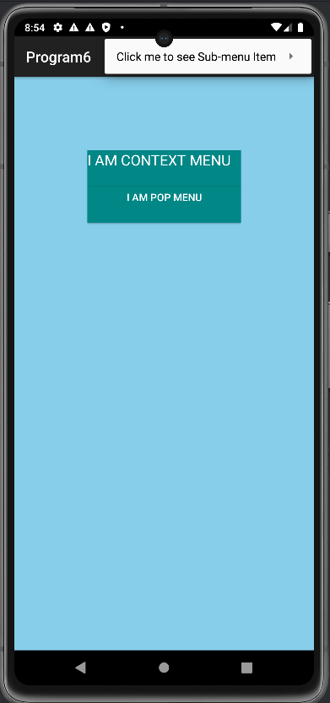
Output:
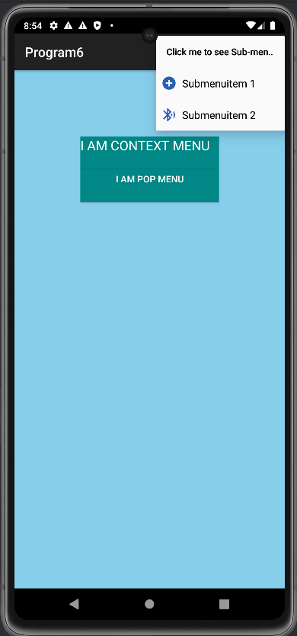
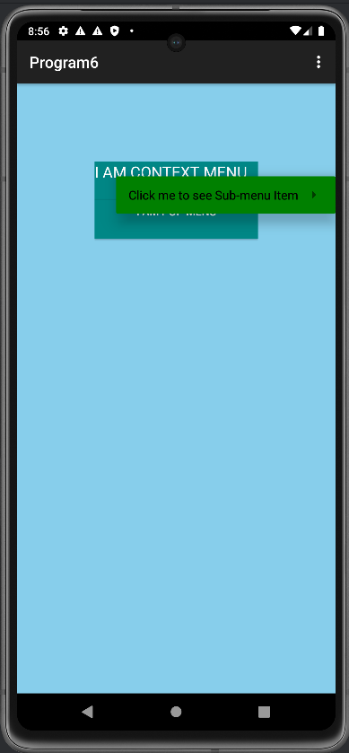
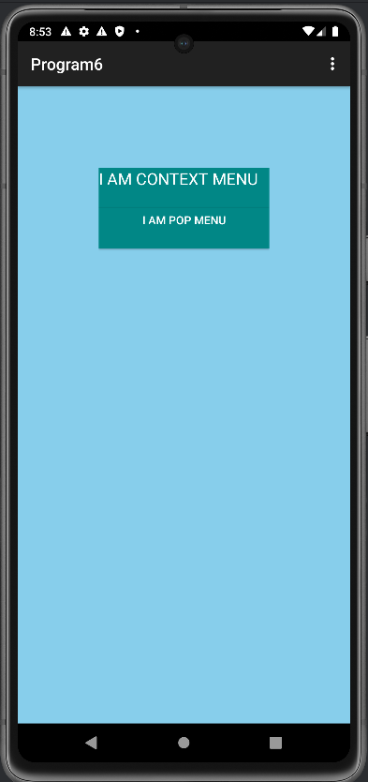
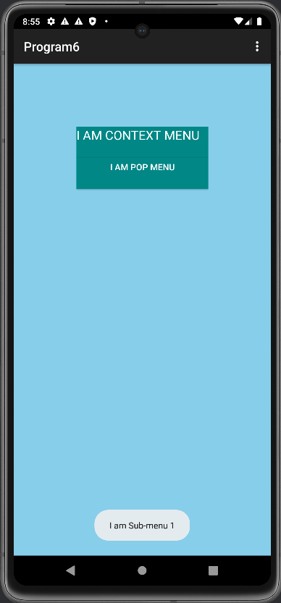
Long press on Context Menu to view the Option.
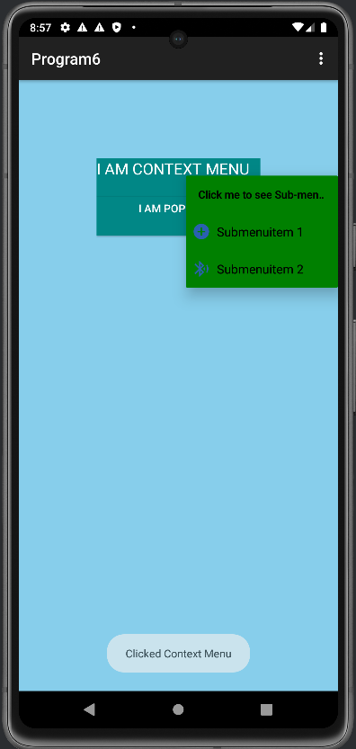

7. Create Simple Calculator in Android Application.

Activity_main.xml File:

<?xml version="1.0" encoding="utf-8"?>
<androidx.constraintlayout.widget.ConstraintLayout xmlns:android="http://schemas.android.com/apk/res/android"
xmlns:app="http://schemas.android.com/apk/res-auto"
xmlns:tools="http://schemas.android.com/tools"
android:layout_width="match_parent"
android:layout_height="match_parent"
android:padding="16dp"
android:background="@color/aqua"
tools:context="MainActivity">

<TextView
android:layout_width="match_parent"
android:layout_height="wrap_content"
android:text="Simple Calculator"
android:textColor="@color/black"
android:textStyle="bold"
android:textAlignment="center"
android:textSize="30dp"
app:layout_constraintEnd_toEndOf="parent"
app:layout_constraintStart_toStartOf="parent"
app:layout_constraintTop_toTopOf="parent"/>

<EditText
android:id="@+id/num1EditText"
android:layout_width="0dp"
android:layout_height="48dp"
android:layout_marginTop="44dp"
android:hint="Enter number 1"
android:inputType="numberDecimal"
app:layout_constraintEnd_toEndOf="parent"
app:layout_constraintStart_toStartOf="parent"
app:layout_constraintTop_toTopOf="parent" />

<EditText
android:id="@+id/num2EditText"
android:layout_width="0dp"
android:layout_height="48dp"
android:layout_marginTop="12dp"
android:hint="Enter number 2"
android:inputType="numberDecimal"
app:layout_constraintEnd_toEndOf="parent"
app:layout_constraintHorizontal_bias="0.47"
app:layout_constraintStart_toStartOf="parent"
app:layout_constraintTop_toBottomOf="@+id/num1EditText" />

<Button
android:id="@+id/addButton"
android:layout_width="wrap_content"
android:layout_height="wrap_content"
android:layout_marginTop="20dp"
android:text="+"
android:textSize="16sp"
app:layout_constraintStart_toStartOf="parent"
app:layout_constraintTop_toBottomOf="@+id/num2EditText" />

<Button
android:id="@+id/subtractButton"
android:layout_width="wrap_content"
android:layout_height="wrap_content"
android:layout_marginTop="20dp"
android:text="-"
android:textSize="16sp"
app:layout_constraintEnd_toStartOf="@+id/multiplyButton"
app:layout_constraintStart_toEndOf="@+id/addButton"
app:layout_constraintTop_toBottomOf="@+id/num2EditText" />

<Button
android:id="@+id/multiplyButton"
android:layout_width="wrap_content"
android:layout_height="wrap_content"
android:layout_marginTop="20dp"
android:text="x"
android:textSize="16sp"
app:layout_constraintEnd_toEndOf="parent"
app:layout_constraintTop_toBottomOf="@+id/num2EditText" />

<Button
android:id="@+id/divideButton"
android:layout_width="wrap_content"
android:layout_height="wrap_content"
android:layout_marginTop="20dp"
android:text="/"
android:textSize="16sp"
app:layout_constraintStart_toStartOf="parent"
app:layout_constraintTop_toBottomOf="@+id/addButton" />

<Button
android:id="@+id/sqrtButton"
android:layout_width="wrap_content"
android:layout_height="wrap_content"
android:layout_marginTop="20dp"
android:layout_marginEnd="140dp"
android:text="Sqrt"
android:textSize="16sp"
app:layout_constraintEnd_toEndOf="parent"
app:layout_constraintTop_toBottomOf="@+id/subtractButton" />

<TextView
android:id="@+id/resultTextView"
android:layout_width="84dp"
android:layout_height="41dp"
android:layout_marginStart="4dp"
android:layout_marginTop="40dp"
android:textStyle="bold"
android:text="RESULT: "
android:textSize="18sp"
app:layout_constraintStart_toStartOf="parent"
app:layout_constraintTop_toBottomOf="@+id/divideButton" />
</androidx.constraintlayout.widget.ConstraintLayout>

MainActivity.java File:

package com.asha.calculator;

import android.os.Bundle;
import android.view.View;
import android.widget.Button;
import android.widget.EditText;
import android.widget.TextView;
import android.widget.Toast;

import androidx.appcompat.app.AppCompatActivity;

import com.asha.calculator.R;

import java.text.DecimalFormat;

public class MainActivity extends AppCompatActivity {

// Declare variables to hold references to UI elements
private EditText num1EditText, num2EditText;
private TextView resultTextView;

@Override
protected void onCreate(Bundle savedInstanceState) {
super.onCreate(savedInstanceState);
setContentView(R.layout.activity_main);

// Initialize UI elements from the layout
num1EditText = findViewById(R.id.num1EditText);
num2EditText = findViewById(R.id.num2EditText);
resultTextView = findViewById(R.id.resultTextView);

// Set click listeners for arithmetic operation buttons

Button addButton = findViewById(R.id.addButton);
addButton.setOnClickListener(new View.OnClickListener() {
@Override
public void onClick(View v) {
performCalculation('+');
}
});

Button subtractButton = findViewById(R.id.subtractButton);
subtractButton.setOnClickListener(new View.OnClickListener() {
@Override
public void onClick(View v) {
performCalculation('-');
}
});

Button multiplyButton = findViewById(R.id.multiplyButton);
multiplyButton.setOnClickListener(new View.OnClickListener() {
@Override
public void onClick(View v) {
performCalculation('*');
}
});

Button divideButton = findViewById(R.id.divideButton);
divideButton.setOnClickListener(new View.OnClickListener() {
@Override
public void onClick(View v) {
performCalculation('/');
}
});

Button sqrtButton = findViewById(R.id.sqrtButton);
sqrtButton.setOnClickListener(new View.OnClickListener() {
@Override
public void onClick(View v) {
calculateSquareRoot();
}
});
}

private void performCalculation(char operator) {
// Get the values entered in the input fields
String num1Str = num1EditText.getText().toString();
String num2Str = num2EditText.getText().toString();

// Check if either input field is empty
if (num1Str.isEmpty() || num2Str.isEmpty()) {
Toast.makeText(this, "Please enter both numbers", Toast.LENGTH_SHORT).show();
return; // Exit the method to prevent calculations with empty inputs
}

// Convert the input values to numeric format
double num1 = Double.parseDouble(num1Str);
double num2 = Double.parseDouble(num2Str);
double result = 0;

// Perform the selected calculation based on the operator
switch (operator) {
case '+':
result = num1 + num2;
break;
case '-':
result = num1 - num2;
break;
case '*':
result = num1 * num2;
break;
case '/':
if (num2 != 0) {
result = num1 / num2;
} else {
Toast.makeText(this, "Cannot divide by zero", Toast.LENGTH_SHORT).show();
return; // Exit the method if division by zero is attempted
}
break;
}

// Format and display the calculation result
DecimalFormat df = new DecimalFormat("#.##");
resultTextView.setText("Result: " + df.format(result));
}

private void calculateSquareRoot() {
String num1Str = num1EditText.getText().toString();
// Check if the input field is empty
if (num1Str.isEmpty()) {
Toast.makeText(this, "Please enter a number", Toast.LENGTH_SHORT).show();
return; // Exit the method to prevent calculations with empty inputs
}

double num = Double.parseDouble(num1Str);
double sqrtResult = Math.sqrt(num);
DecimalFormat df = new DecimalFormat("#.##");
resultTextView.setText("Square Root: " + df.format(sqrtResult));
}
}
Output:

